 |  |  |  | 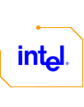
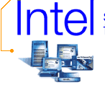 |   Providing the technology that helps people connect. In business. At home. Online. | 

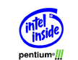
  Desktop PCs. Power, compatibility, reliability — for today and the future
  Mobile PCs. Go mobile — run demanding applications, work the Web, anywhere
  Servers. Launch your future — technology to take your business online

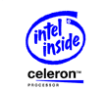
  Desktop PCs. Proven smart — Intel quality and reliability at a great value
  Mobile PCs. Affordable productivity — Run core applications and access the Internet, anywhere


  Networking Products. Get connected — with flexible, affordable solutions for the desktop, office and Internet
  Anypoint Home Networking. Surf city — build a home network of PCs with existing phonelines and get everyone online at once
  Intel® PC Cameras. Picture this — connect with family and friends with video e-mail or video phone

